

**Placement Empowerment Program**

**Cloud Computing & DevOps Center**

**Deploy your Static Website-Github pages:** Host your local Git repository’s static website directly using github pages.

**Name:** Pranav Karunakaran

**Dept:** IT

**INTRODUCTION**

* GitHub Pages is a powerful, free hosting service provided by GitHub that allows you to deploy static websites directly from your local Git repositories. With VDeploy, you can streamline this process, making it simple and efficient to get your static site online with just a few steps.
* Whether you're working on a portfolio, documentation, or a simple project website, GitHub Pages lets you publish directly from your repository without complex server configurations

**OBECTIVE OF THIS TASK**

The objective of this guide is to provide a seamless approach to deploying static websites directly from your local Git repositories using GitHub Pages. By leveraging this powerful and cost-effective hosting solution, developers can quickly host and manage static content, such as personal portfolios, project documentation, and simple web applications, without the need for complex server configurationns.

**Step-by-step process:**

**Step 1:** Create a new github repo in your account.

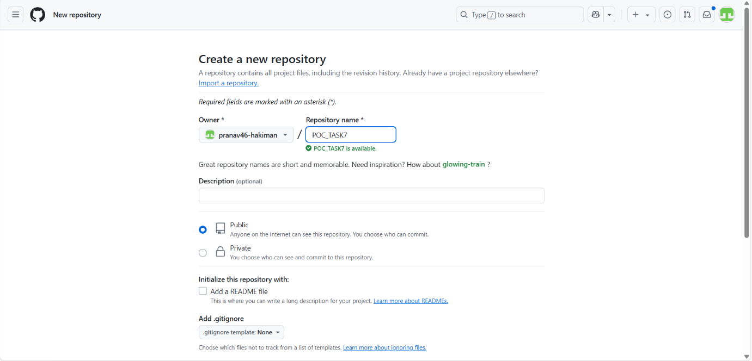

**Step 2:** Create a folder and in that folder create a new html file for your website.

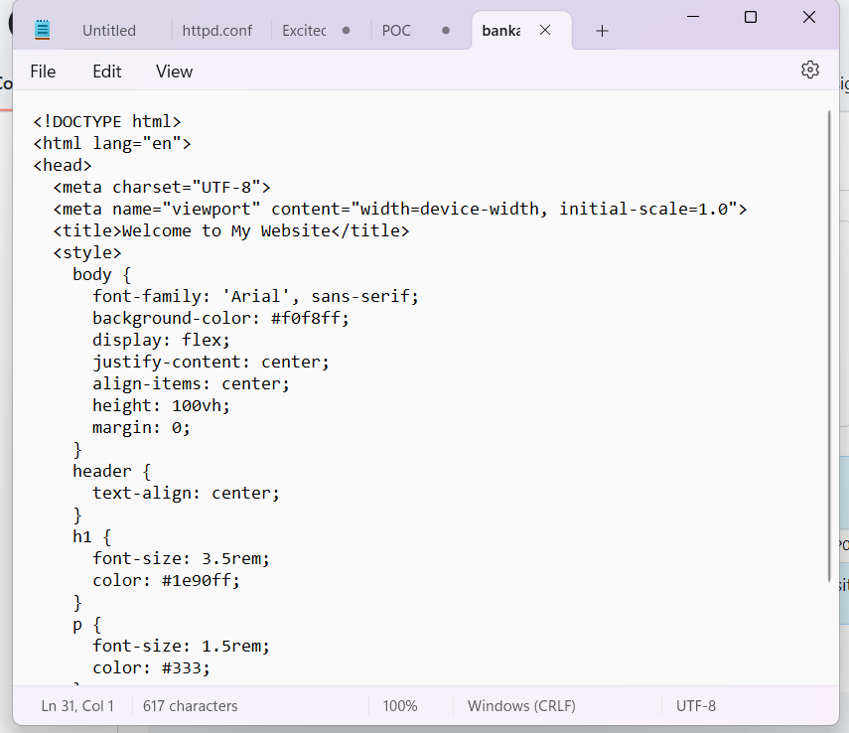

**Step 3**: Open the “Cmd prompt” as a user and open the folder you created.

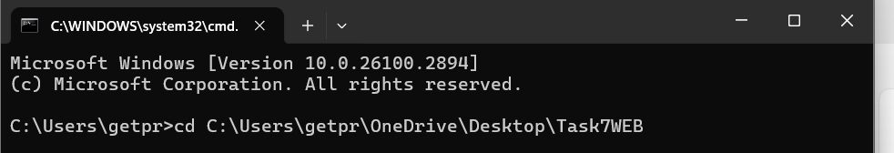

**Run the following Git cmds:**

1. Git init
2. Git add .
3. Git commit -m “Zanka no Tachi”
4. Git branch -M main

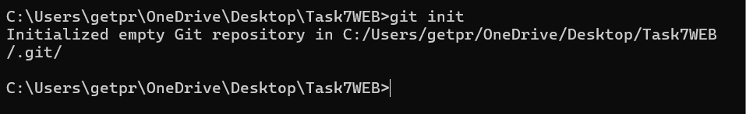

**Here add the path of your github repo**

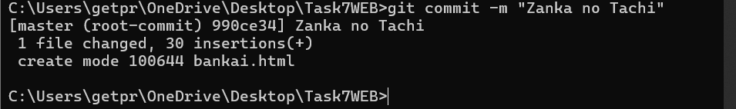



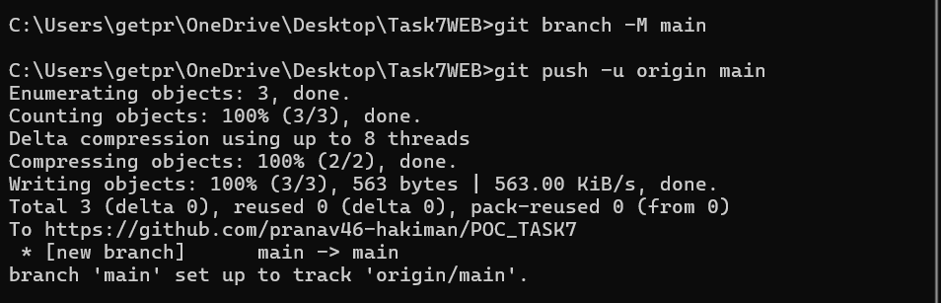

**Step 4:** Now go to your Github and in settings, go to the pages section. Then Enable pages. Once done with changes click on save.

Changes to be made:

* Branch – main
* Folder - root

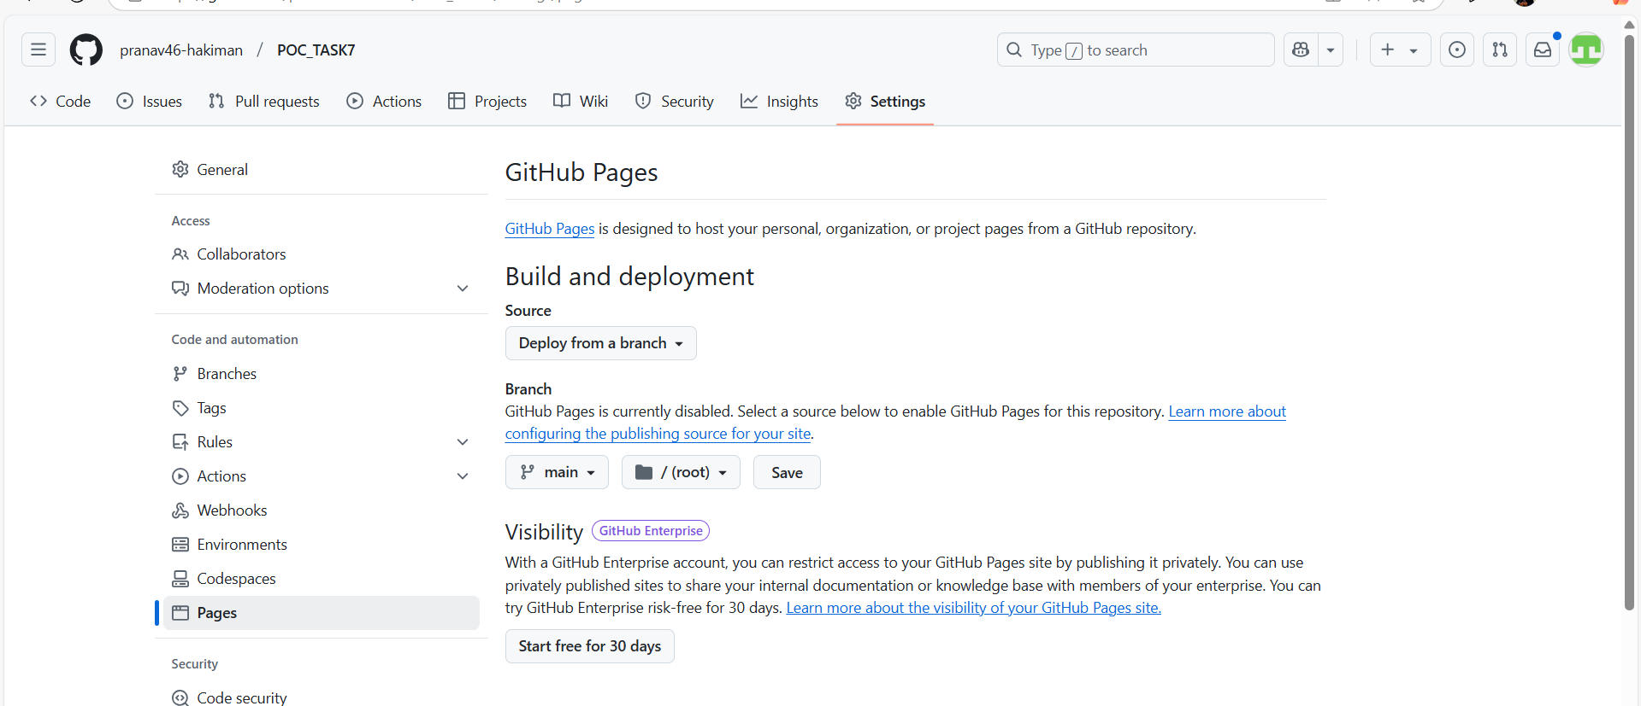

**Step 5:** You get to access your website:

